# Problem - Solution Fit: Pattern Sense - Classifying Fabrics Using Deep Learning

## 1. CUSTOMER SEGMENT(S)

Textile manufacturers, fashion designers, and quality control teams in the apparel industry.

## 2. JOBS-TO-BE-DONE / PROBLEMS

Quickly and accurately identify and classify fabric patterns (e.g., plain, twill, satin) to streamline quality assurance and production processes.

## 3. TRIGGERS

Increased demand for automated quality inspection, reduction of manual labor costs, need for higher accuracy in pattern recognition.

## 4. EMOTIONS: BEFORE / AFTER

Before: frustrated, prone to errors, time-consuming process.  
After: confident, accurate, efficient and fast classification.

## 5. AVAILABLE SOLUTIONS

Manual inspection by experts, basic image processing techniques. Pros: low-tech; Cons: inconsistent, time-consuming, labor-intensive.

## 6. CUSTOMER CONSTRAINTS

Limited budget for automation, lack of in-house AI expertise, data privacy concerns.

## 7. BEHAVIOUR

Manually compare fabric samples, use microscopes or handheld devices to identify weave patterns.

## 8. CHANNELS of BEHAVIOUR

8.1 ONLINE: Research AI-based QC systems, watch demo videos, read textile innovation blogs.  
8.2 OFFLINE: Attend textile expos, consult with machine vision vendors.

## 9. PROBLEM ROOT CAUSE

Traditional visual inspections are subjective and inconsistent, and human errors often lead to costly production mistakes.

## 10. YOUR SOLUTION

A deep learning model (e.g., CNN) trained on labeled fabric images to automatically classify patterns with high accuracy. Integration with camera systems enables real-time inspection.

## CNN Architecture Diagram

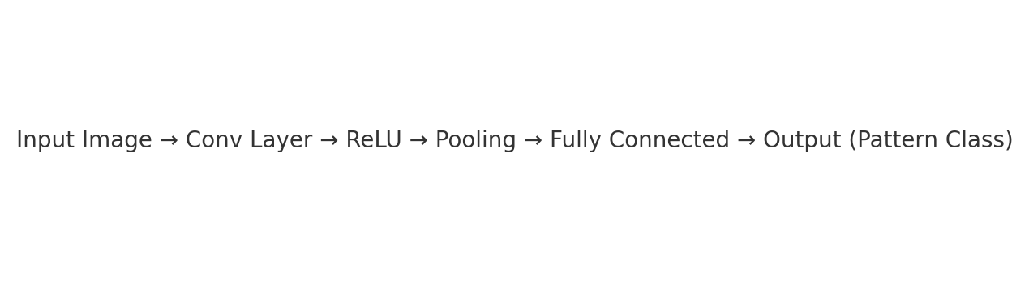

## Sample Confusion Matrix

